Location: 5833 Meeting House Rd, Tully, 13159 March 4, 2026
Members’ Present: | Others Present:
Mayor Daniel Ray  Deputy Mayor Eric Galvin  Trustee Roxanne Oliver  Trustee Kaula Pisano  Trustee Luke Zimmerman | Maureen Bibik-Clerk/Treasurer  Thomas Chartrand-Accountant  Benjamin Vincent- Code Enforcer  Micheal Hoke- DPW Supervisor  Ben Bibik  Frank Speziale  Ava Sullivan  Gordon Sullivan  Matt Daly
Absent: Courtney Hills-Attorney (Available by phone)

Call to Order

March 4th, 2026: Budget Workshop 5:00pm with regular board meeting to follow

There was a budget meeting @ 5:00pm with a regular meeting of the Board of Trustees of the Village of Tully to follow on Wednesday, March 4th, 2026, at 7:00pm in the Municipal Building.

Mayor Dan Ray led the Pledge of Allegiance and called the meeting to order at 5:34pm.

Approval of Minutes
The minutes of the meeting were made available via email to all board members.

Motion was made by Trustee Oliver, 2nd by Trustee Galvin to approve the minutes from the February 4th, 2026 meeting. All ayes carried
`

TREASURERS Report
Tom reviewed receipts and disbursements as follows:
Receipts and Interest: Interest rates remain approximately 3.5% for both the NYCLASS and NBT accounts. Gross receipts taxes were recorded. Quarterly franchise fees were received, though projections were reduced.
Fund Activity
- Water Fund: Interest income, late water bill payments, and one water-related meeting.
- Sewer Fund: Minimal billing activity.
- Trust and Agency Fund: Payroll accumulator activity.
Spending Highlights
- General Fund: Minimal expenditures.
- Water Fund: Approximately $87,000 expended, primarily for the annual bond payment on the water tower and water line. This obligation has been fully satisfied for the year.
Bonding Status
- Old Route 80 Water Project: Final payment of $40,000 completed; balance is now zero.
- Rural Development Bond: Original principal of $2,346,000; $57,000 paid to date; current balance is $2,289,000. The next payment is due in October.
Bonding Overview
The only remaining active bond is the original $3.2 million issuance, structured over an estimated 30-year term, with approximately 25 years remaining.
Budget Performance
- General Fund: Expenditures at approximately 16% (lower due to reserve balances); revenues at approximately 70%.
- Sewer Fund: Expenditures at approximately 42%, with higher activity expected later in the year.
- Water Fund: Revenues at approximately 75%.

The Accountant discussed the need to transfer funds for the General Fund and Sewer Fund. From General Contingent to General Snow Removal, and Sewer contractual to Sewer Medical Insurance.

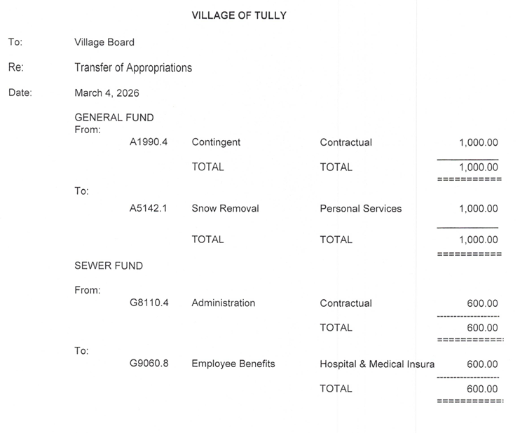
Upon motion made by Mayor Ray, 2nd by Trustee Zimmerman, to approve the Transfer of Appropriations. All ayes carried.
Upon motion made by Mayor Ray, 2nd by Trustee Oliver, to accept February 2026 Treasurer’s Report. All ayes carried.
Upon motion made by Trustee Pisano, 2nd by Trustee Zimmerman, to accept the bank reconciliations, subject to audit. All ayes carried.

Public Comment
None

DPW/Engineer
SPDES Permit Status
- The wastewater treatment plant permit was scheduled to expire on February 28; renewal materials were submitted in September.
- In February, DEC initiated a permit reevaluation, which extended the current permit and shifted associated deadlines to April.
- One DEC letter indicates permit renewal through 2031.
- Subsequent DEC communications state that reevaluation is required prior to permit reissuance.
- A call with the DEC regulator is scheduled for next week.
- Laboratory expenditures are on hold pending resolution.
- The team intends to complete the long form review while minimizing additional DEC scrutiny.
The last comprehensive review of this type occurred in 2009.
Banner Farm/Banner Road – Potter Lease Renewal:
Jim Potter (farm operations) seeks renewal. Board consensus is to renew as-is unless changes are needed. Add a clause prohibiting manure spreading on leased land. Address the inclusion of approximately 2–2.5 acres of fire district land, permitting planting activities until reclamation occurs.
Manure applications could complicate sludge compliance testing and reporting, particularly if external manure is introduced. While past data was inconclusive, the risk remains. Treated as a minor change unless objections arise. DEC input will be sought if necessary.

Brush Drop-Off Policy Changes:
Large trees and debris consume excessive DPW time (e.g., two full days). New policy (to be mailed with April water bills):
- Maximum brush diameter: 6 inches
- Maximum weight: 50 pounds
- Service limited to Village residents only to avoid confusion with Town residents
Operational Note: A scale will be available if requested.

Critical Equipment – Emergency Pump (4-inch)
The Village’s portable emergency sewer pump (purchased in 2002) needs a motor replacement due to failure. The repair cost is $2,525 and should be completed immediately to keep an on-site backup available. Staff will begin planning for a future replacement. The repair will be charged to the General Fund machinery line.
ONONDAGA ST. MAINTENANCE PLAN:
Onondaga Street was milled and repaved with hot-mix asphalt in 2019, followed by micro-paving treatments in 2020 and 2022 to help preserve the pavement surface. Despite these efforts, the roadway’s relatively flat profile has led to ongoing drainage issues. Standing water frequently remains on the pavement after rain events, which accelerates surface wear and contributes to premature deterioration. To address these underlying conditions, funds are being set aside for a comprehensive long-term drainage improvement project. This project is expected to include the installation of catch basins and related drainage infrastructure to correct the drainage deficiencies and provide a sustainable, long-term solution.

2026 Maintenance Plan:
Short-term maintenance will focus on preserving the existing pavement condition. This includes patching distressed areas with hot-mix asphalt and applying a cape seal (oil application with fine aggregate) to protect the surface and extend the roadway’s service life until full drainage improvements can be completed.

Counsel
None.

Codes
Fire inspections last week, and will continue into next week. ZBA Confusion: Last month only one ZBA member showed up for a special permit hearing. ZBA is desperate to make quorum. An old ZBA member will be renewing his oath of office, and there is one more interested party, so hopefully the special permit hearing can happen later this month.

Old Business
None.

New Business
May 9th, 2026 is the Village/Town Dump Day.

Public Comment
Appointments, Recognitions, and Announcements
- Condolence: The Board noted with sadness the passing of Alvah Cook Jr., former Village Trustee (1983–1988) and Mayor (1988–1990), over the weekend. Services are not yet scheduled. The Board discussed sending a flower arrangement funded by personal contributions.
- Certification: Mike reported an increase in his wastewater certification after successfully passing a final exam.
- Oath of Office: Matthew Daly was sworn in as a ZBA member.
New residents, the Sullivan’s, introduced themselves, noting they recently moved from Pompey and attended due to interest in the “Banner” agenda item. The Board welcomed them to Tully.

Audit Bills
Upon motion made by Trustee Oliver, 2nd by Mayor Ray, to have the Accountant pay the bills, subject to audit. All ayes carried.

Budget:
Upon motion made by Trustee Galvin, 2nd by Trustee Oliver, to change Mike Hoke’s title to Superintendent of Public Works. All ayes carried.

Upon motion made by Mayor Ray, 2nd by Trustee Pisano, to increase Mike Hoke’s salary from $68,000/year to $105,000/year effective March 2, 2026. All ayes carried.

Upon motion made by Mayor Ray, 2nd by Trustee Galvin, to have the Village Clerk write a letter to end the contract with Koesters effective February 21st, 2026. All ayes carried.

Upon motion by Trustee Galvin, 2nd by Mayor Ray, it was unanimous to move the tentative budget to preliminary status. All Ayes carried.

Upon motion by Mayor Ray, 2nd by Trustee Zimmerman, to have a public hearing on the preliminary budget on April 8th, 2026, at the Municipal Building for 6:30PM, with the regular board meeting to follow. All Ayes carried.

Upon motion made by Trustee Galvin, and 2nd by Trustee Oliver, to cancel the March 18th, 2026, tentative budget meeting. All ayes carried.

Upon motion made by Trustee Oliver, 2nd by Trustee Pisano, to have the Village Clerk put a notice in the Post Standard stating the Budget Hearing for April 8th, 2026, at 6:30pm with the regular meeting to follow. All ayes carried.

The preliminary budget will be posted on the Village website. The preliminary budget includes compensation for the Mayor of $4,000.00 per annum and for each of the Trustees of $950.00 per annum. A summary of the preliminary budget is as follows: Taxes to be raised for General Fund $255,964.00; Water Assessment $93,162.56, Sewer Assessment $112,392.09. The amount to be raised through user fees is as follows: Water Fund $243,126.00; Sewer Fund $548,889.00.

Close of Meeting

Upon motion made by Mayor Ray, 2nd by Trustee Galvin, it was unanimous to adjourn at 8:10PM.

Certifications (Open Meetings Law §106 Compliance)
These minutes capture motions, proposals, resolutions, and their votes, and summarize other matters discussed at the open meeting. Any documents adopted herein are on file with the Village Clerk.

Respectfully Submitted by:

__________________________________
Maureen Bibik
Clerk/Treasurer
Village of Tully
DATED: March 11, 2026
Approved by the Village Board on: ______4/8/2026______________, 2026 (as written / as amended)

Attachments (on file with Clerk)
- Monthly Financial Abstract & Transfers Sheets

