Location: 5833 Meeting House Rd, Tully, 13159 February 04, 2026
Members’ Present: | Others Present:
Mayor Daniel Ray  Deputy Mayor Eric Galvin  Trustee Roxanne Oliver  Trustee Kaula Pisano  Trustee Luke Zimmerman | Thomas Chartrand-Accountant  Micheal Hoke- DPW Supervisor  Frank Speziale  Ben Bibik  Erin Goodfellow  Ben Cutter-MRB
Absent: Maureen Bibik- Clerk/Treasurer, Benjamin Vincent- Code Enforcer, Courtney Hills-Attorney (Available by phone)

Call to Order
Mayor Ray led the Pledge of Allegiance at 7:00 pm.

Approval of Minutes
The minutes of the meeting were made available via email to all board members.
Upon motion made by Trustee Galvin, 2nd by Trustee Zimmerman, to approve January 7th Organizational and Regular meeting minutes. All ayes carried.

TREASURERS Report
Tom reviewed receipts and disbursements as follows:
- NYCLASS and NBT high-interest accounts are at approximately 3.5%. The Treasurer advised there is no meaningful advantage to moving funds at this time.
- General Fund Revenues: Building permit revenue, gross receipts tax, and county reimbursement of tax penalties were received. Mortgage tax was approximately $2,400 favorable for the year, while PILOT revenue was about $700 short; overall, the Village remains ahead. A small insurance recovery was noted.
- Water & Sewer Revenues: Water use fees are at 58% of budget, sewer use fees at 49%—both consistent with expectations after the first billing cycle.
- Abstracts/Notable Expenditures: General Abstract #8 included a significant PILOT distribution (~$20,000). The Water Abstract included the final bond payment for the Route 80 water project. The Sewer Abstract included a major bill of ~$15,000, with year-to-date spending at $61,000 against a $60,000 budget, requiring transfers.
- Fund Status: General Fund spending is approximately 17%; the fund remains in good condition. Sewer spending is at 59% with revenues at 60%, making it the primary budget concern. Water spending is at 28% with revenues at 75%.
- Budget Transfers: Transfers were presented for both the General Fund (from contingency to administration/buildings/equipment/checks & assessments) and the Sewer Fund (to address the
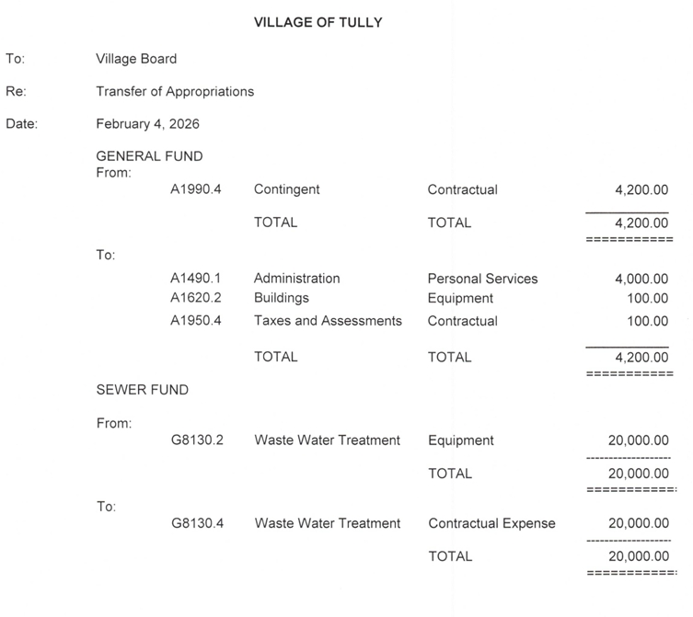
overage).

Upon motion made by Trustee Galvin, 2nd by Mayor Ray, to accept the Accountants transfer of appropriations. All ayes carried.

Budget Calander and Budget Workshops:
- Departmental Estimate letters will be sent out by February 8th.
- Each department needs to turn in Yearly Budget Estimates to the Village Clerk no later February 20th, 2026.
- Proposed budget workshop date and time will be March 4th with an additional tentative budget workshop for March 18th. There is a proposed budget hearing for the public on April 15th.

Upon motion made by Mayor Ray, 2nd by Trustee Galvin, to have the first budget workshop on March 4th at 5pm with regular meeting to immediately follow, and to have the Clerk post ad in the Post Standard providing such time and date. All ayes carried.

Upon motion made by Mayor Ray, 2nd by Trustee Pisano, to schedule a second budget workshop for March 18th at 7pm (if need be), and to have the Clerk included in the same legal notice/advertisement as the March 4th Budget Workshop ad. All ayes carried.

Accountant Chartrand stated that he might not be able to attend the April 1st Village Board regular meeting, and requests to move the regular meeting to April 8th. The decision has been tabled to March’s regular meeting on March 4th.

Accountant Chartrand wanted to let the Board know that the Greater Tompkins County Municipal Health Insurance Consortium will no longer accept checks as payments for health insurance payments starting March 2026. The Accountant wanted to let the Board know it would significantly increase workload.
Accountant Chartrand stated intent to continue working with the Village through June 2027 (correcting an initial misstatement that caused concern).
No formal Board action taken at this time (paperwork not yet completed).

Public Comment
None.

DPW/Engineer

January 2026 flows

5.260 million gallons treated at WWTP

Average 170,000 gallons per day

191.25 hours worked at WWTP

2.580 million gallons produced at wells

83,000 gallons per day average

MRB: Land Spreading Proposal- Ben referenced a proposal previously sent to the Board regarding land spreading reporting/requirements, described as time-sensitive, needing completion before March 1.

• Fee discussed: $7,500, “hourly not to exceed,” with intent to complete for less if possible.

• Ben explained this reporting is an annual update process and future years should be less costly now that baseline data is established.

• Discussion noted this work related to the 2025 reporting year and would be paid from the current budget year (and the Board noted the sewer budget is already significantly overspent). Board asked that DPW Hoke consider budgeting for anticipated future-year land spreading/reporting costs.

Upon motion made by Trustee Pisano, 2nd by Trustee Oliver, to authorize Mayor Ray execution/signature of the land spreading agreement. All ayes carried.

MRB: Change Order Form- Ben presented a change order for a telescopic valve (project details referenced as drawings/updates).
• Cost presented: approximately $5,600.
• Ben noted an existing project allowance of approximately $2,500, implying net effect around $3,500 (clarified that it is “not spending” rather than receiving a refund check).

Upon motion made by Trustee Oliver, 2nd by Mayor Ray, to approve the change order for the telescopic valve and authorize Mayor Ray to sign the contract. All ayes carried.

Regulatory/DEC Preparation (Mercury/PFAS)
Discussion referenced emerging regulatory scrutiny and the possibility of new limits/requirements (mercury and PFAS). Ben (MRB) indicated the Board could be involved in an upcoming meeting and that scheduling would be needed within the next few weeks.

Equipment Sale – Tractor (Auction)
Discussion referenced a tractor auction sale and authorization needs:
• Sale price had increased from an earlier figure (~$6,000) to $18,700.00.
• For reference, the tractor and attachments purchased new in 2010 for $41,141.60.
• Process described: the auction company collects funds, remits payment to the Village, and only then is the item released.

Upon motion made by Trustee Galvin, 2nd by Mayor Ray, to approve the sale of the tractor for $18,700.00, and to authorize Mayor Ray or Clerk Bibik sign the bill of sale upon receipt of payment. All ayes carried.

Truck Replacement – 2011 Small Dump Truck
Hoke reported the Village has been budgeting for several years to replace the 2011 small dump truck, with $100,000 set aside.
A. Purchase Option Reviewed
Hoke presented a proposal to purchase a complete truck on county contract:
• Vehicle: 2026 Ford F-450 XL regular cab, 4x4
• Includes: stainless steel box, lights, hoist, plow, etc. (turnkey, “done deal”)
• Total: $100,586
• County contract reference: Onondaga County bid number 0011171
• Vendor referenced: Van Bortel Ford (Village prior experience noted)
Board discussed alternatives (chassis-only then separate body build) but concluded time/effort savings favored complete purchase.
Hoke stated the Village expects proceeds from selling the old truck, estimating $30,000–$35,000, though sale timing may not occur within the current year.
Upon motion made by Mayor Ray, 2nd by Trustee Galvin, to purchase the 20026 Ford F-450XL from dealer by county contract # 0011171 for $100,586. All ayes carried.

Generator Project Update
Hoke reported the backup generator is installed and wired and is close to usable, but final work requires:
• drilling/mounting in concrete,
• final startup,
• and better weather conditions.
Work is delayed due to weather.

Curbside Pickup / Brush Policy Discussion
Board discussed updating the curbside pickup schedule and clarifying rules for brush pickup due to repeated abuse of the service:
• Village logged approximately 69 hours of brush chipping time in the past year.
• Examples were cited of residents placing large tree removal debris at the curb, including full trees and large trunk sections, resulting in excessive Village labor.
• Board discussion emphasized intent of service is routine brush/limb cleanup, not tree removal.
Consensus points discussed for draft policy edits:
• “Brush only” and no tree trunks/trees.
• Consider language distinguishing normal downed limbs vs. full-scale tree removal.
• Board debated whether to include a size limit; several members expressed preference for no size specification, but ensuring clarity so residents cannot exploit loopholes.
• Consideration of charging an hourly rate (or threshold) for excessive chipping/pickup beyond a set amount.
No final written policy adopted during this meeting; Hoke indicated he would work on editing language for the schedule/policy.

COUNSEL
None

Codes
Code Enforcement Officer Vincent was unable to attend and texted that he had nothing to report.

Old Business
Precinct/Building Use – Robotics Group Agreement & Key Control
Board discussed use of a Village precinct building space by a junior/senior high school robotics group (conflict-of-interest disclosure noted by a speaker whose son is a member).
• The group had historically been allowed to use the space without a formal liability/insurance agreement.
• Board expressed the need to formalize the arrangement via an agreement.
• Insurance coverage was stated to be through the Town (parks and recreation).
• Board discussed key control and suggested maintaining a log of who has keys.
• A heating concern was mentioned; building heat set at 55°F and may not have kept up during recent cold weather; Village has accessed building and indicated thermostat can be adjusted for use.
No formal motion recorded in transcript; direction was to proceed with agreement/administrative follow-up.

New Business
Grants / State Infrastructure Funding
Board discussed reports that Governor Hochul’s budget may include significant funding for local infrastructure.
• Board discussed consulting with MRB and/or Bill regarding what grant opportunities may apply to the Village.
• General discussion on grant process: sometimes the Village identifies opportunities and brings them to MRB; other times MRB identifies programs and assists with applications. Board noted the need to avoid “double dipping” where grants cannot overlap for the same project purpose.

Employee Handbook – Vacation Time Clarification
Board reviewed an email request from employee Brissette regarding vacation accrual and prorating based on start date and fiscal year.
• Handbook language referenced: vacation computed using June 1 as anniversary date; partial year prorated.
• Accountant Chartrand calculated that if start date was July 15, the employee would have accrued approximately 70 hours for that partial year.
• Board requested Accountant Chartrand to send an email clarification to the employee to ensure accurate communication.
No formal motion required.

Community Days / Celebrations Account Balance
Trustee Oliver asked about leftover funds from Community Days.
• Accountant reported approximately $1,414 remaining in the celebrations account.
• Accountant advised that planning for September 2026 should be included in the upcoming budget request (new fiscal year begins June 1).
• Trustee Oliver was advised to include budget needs in the budget letter under “any other areas of concern.”

Public Comment

DPW Hoke is scheduled to take his Supervisory Exam on February 24th, 2026.

Tax Cap Override – Preparatory Legal Draft
Discussed potential need for a tax cap override local law if the budget process indicates exceeding the state tax cap (referenced as 2%).
• Accountant Chartrand suggested the Board request that Attorney Hills prepare a draft local law for the March meeting, so the Board could review it and, if needed, schedule a public hearing in April.
• Purpose described: if taxes need to exceed the cap to fund required projects, the Village must pass a local law; otherwise amounts above the cap cannot be used as intended.

Audit Bills
Upon motion made by Trustee Oliver, 2nd by Trustee Zimmerman, to accept the Bank Reconciliation. All ayes carried.

Upon motion made by Trustee Galvin, 2nd by Mayor Ray, to authorize the Accountant to pay the bills, subject to audit. All ayes carried.

Close of Meeting
Upon motion made by Trustee Oliver, 2nd by Mayor Ray, to adjourn the meeting at 8:08pm. All ayes carried.

Certifications (Open Meetings Law §106 Compliance)
These minutes capture motions, proposals, resolutions, and their votes, and summarize other matters discussed at the open meeting. Any documents adopted herein are on file with the Village Clerk.

Respectfully Submitted by:

__________________________________
Maureen Bibik
Clerk/Treasurer
Date: February 13, 2026
Approved by the Village Board on: __March 4__, 2026 (as written / as amended)

Attachments (on file with Clerk)
- Monthly Treasury Report
- Land Spreading Agreement
- Change Order N0. G C-02

